**#22092** - <https://redmine.vnc.biz/issues/22092>

1. **Description**:

Just like in the About-Panel-Tab in zimbra, display vnctalk version on the admin panel. So the admin can see which version is installed in zimbra without looking with the bash console.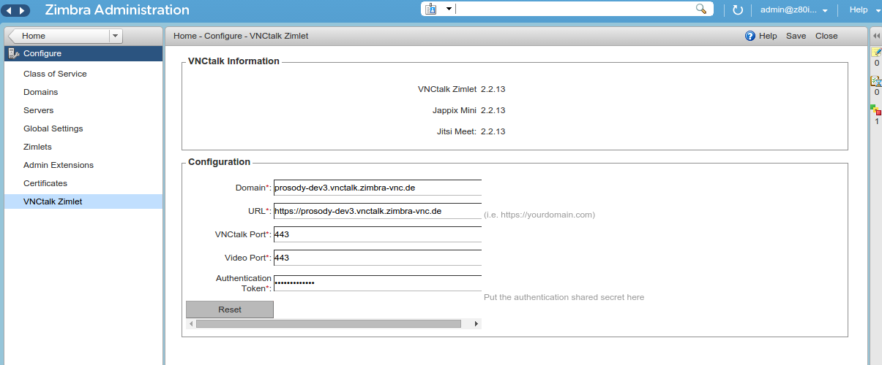

1. **Analytic**
   1. **Root cause**:

* 1. **Solutions**:

1. **Implementation**
   1. **Code:**

Add biz_vnc_admin_talk_zimlet.vnctalk_information_tab

|  |
| --- |
| ZaTalkZimletFormView.myXFormModifier = function(xFormObject) { ...  xFormObject.items = [{  type: _ZATABCASE_,  isTabGroup: true,  id: "chatzimlet_group",  ref: ZaModel.currentTab,  relevant: "instance[ZaModel.currentTab] == 1",  numCols: 1,  colSizes: ["800px"],  caseKey: newTab++,  cssStyle: "padding-top:15px;",  items: [{  type: _ZAALLSCREEN_GROUPER_,  id: "chatzimlet_group_sipgate_vnctalk_info",  width: "100%",  numCols: 1,  colSizes: ["45%"],  label: biz_vnc_admin_talk_zimlet.vnctalk_information_tab,  items: [{  type: _GROUP_,  numCols: 1,  colSizes: ["400px"],  items: [{  ref: ZaTalkZimletTabModel.A_zimlet_version_text,  type: _OUTPUT_,  id: ZaTalkZimletTabModel.A_zimlet_version_text,  label: biz_vnc_admin_talk_zimlet.zimlet_version + " ",  width: 300,  height: 22,  cssStyle: "padding-top: 7px;"   },{  ref: ZaTalkZimletTabModel.A_jappix_mini_version_text,  type: _OUTPUT_,  id: ZaTalkZimletTabModel.A_jappix_mini_version_text,  label: biz_vnc_admin_talk_zimlet.jappix_mini_version + " ",  width: 300,  height: 22,  cssStyle: "padding-top: 7px;"   },  {  ref: ZaTalkZimletTabModel.A_jitsi_meet_version_text,  type: _OUTPUT_,  id: ZaTalkZimletTabModel.A_jitsi_meet_version_text,  label: biz_vnc_admin_talk_zimlet.jitsi_meet_version + ":",  width: 300,  height: 22,  cssStyle: "padding-top: 7px;"   }  ]  }]  },{ ... } |

Add data (zimlet version, jappix mini version, jitsi meet version).

+ ZaTalkZimletTabModel.js

|  |
| --- |
| ZaTalkZimletTabModel.A_zimlet_version_text = "zimlet_version_text";  ZaTalkZimletTabModel.A_jappix_mini_version_text = "jappix_mini_version_text";  ZaTalkZimletTabModel.A_jitsi_meet_version_text = "jitsi_meet_version_text";  ZaTalkZimletTabModel.myXModel = { ...  {  id: ZaTalkZimletTabModel.A_zimlet_version_text,  ref: "attrs/" + ZaTalkZimletTabModel.A_zimlet_version_text,  type: _OUTPUT_  },{  id: ZaTalkZimletTabModel.A_jappix_mini_version_text,  ref: "attrs/" + ZaTalkZimletTabModel.A_jappix_mini_version_text,  type: _OUTPUT_  },{  id: ZaTalkZimletTabModel.A_jitsi_meet_version_text,  ref: "attrs/" + ZaTalkZimletTabModel.A_jitsi_meet_version_text,  type: _OUTPUT_  }] ... } |

+ZaTalkZimletViewController.js

|  |
| --- |
| ZaTalkZimletViewController.prototype.show = function(entry, targetID) { ...  instance.attrs[ZaTalkZimletTabModel.A_zimlet_version_text]=biz_vnc_admin_talk_zimlet.ZIMLET_VERSION;  instance.attrs[ZaTalkZimletTabModel.A_jappix_mini_version_text]=biz_zcs_vnc_talk_zimlet.JAPPIX_MINI_VERSION;  instance.attrs[ZaTalkZimletTabModel.A_jitsi_meet_version_text]=biz_zcs_vnc_talk_zimlet.JITSI_VERSION; ... } |